Round-Robin (RR) Scheduling
# Source: AI Source: Provided by: [Data Path: Persons Table -> ID Column: 1, Name_En Column: Motasem Essam] -> From: [ChatGPT] on [1/21/2026]
Round-Robin (RR) Scheduling is a commonly used time-sharing scheduling algorithm in both operating systems and some real-time systems, particularly for soft real-time applications. It is designed to share CPU time fairly among tasks.

Definition
# Source: AI Source: Provided by: [Data Path: Persons Table -> ID Column: 1, Name_En Column: Motasem Essam] -> From: [ChatGPT] on [1/21/2026]
Round-Robin scheduling assigns a fixed time slice (quantum) to each task in the ready queue.
- Tasks are executed in circular order.
- When a task’s time slice expires, it is preempted, and the CPU moves to the next task.
- The process continues until all tasks are completed.

Key Features
# Source: AI Source: Provided by: [Data Path: Persons Table -> ID Column: 1, Name_En Column: Motasem Essam] -> From: [ChatGPT] on [1/21/2026]
- Time-Slicing: Each task gets a fixed CPU time in a cyclic order.
- Preemptive: Tasks are interrupted when their time quantum expires.
- Fair Allocation: Every task gets a turn in a predictable sequence.
- Good for Soft Real-Time Systems: Can handle multiple interactive or periodic tasks.

Advantages
# Source: AI Source: Provided by: [Data Path: Persons Table -> ID Column: 1, Name_En Column: Motasem Essam] -> From: [ChatGPT] on [1/21/2026]
- Fair to all tasks – no task can monopolize the CPU.
- Simple to implement – uses a circular queue.
- Good for time-sharing systems – ensures all tasks get CPU regularly.

Disadvantages
# Source: AI Source: Provided by: [Data Path: Persons Table -> ID Column: 1, Name_En Column: Motasem Essam] -> From: [ChatGPT] on [1/21/2026]
- Not ideal for hard real-time tasks – may miss deadlines if the time quantum is too long.
- Overhead due to context switching – frequent preemption can waste CPU cycles.
- Doesn’t consider task priority – all tasks are treated equally.

Example
# Source: AI Source: Provided by: [Data Path: Persons Table -> ID Column: 1, Name_En Column: Motasem Essam] -> From: [ChatGPT] on [1/21/2026]
Suppose three tasks with execution times arrive in a system:
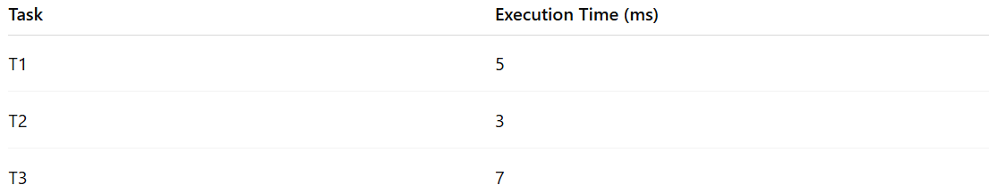
Task | Execution Time (ms)
T1 | 5
T2 | 3
T3 | 7
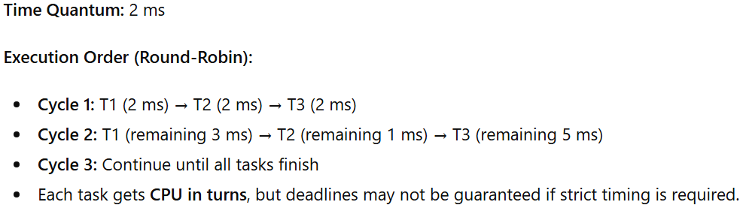
Time Quantum: 2 ms
Execution Order (Round-Robin):
- Cycle 1: T1 (2 ms) → T2 (2 ms) → T3 (2 ms)
- Cycle 2: T1 (remaining 3 ms) → T2 (remaining 1 ms) → T3 (remaining 5 ms)
- Cycle 3: Continue until all tasks finish
- Each task gets CPU in turns, but deadlines may not be guaranteed if strict timing is required.

Why Round-Robin Matters for Software Engineers
# Source: AI Source: Provided by: [Data Path: Persons Table -> ID Column: 1, Name_En Column: Motasem Essam] -> From: [ChatGPT] on [1/21/2026]
- Good for interactive systems, multimedia, and soft real-time applications.
- Teaches time-sharing, preemption, and context switching concepts.
- Provides a foundation for fair CPU scheduling before moving to more complex algorithms like RMS or EDF.

